SCREENING USING GARP METHOD

EXPLANATION
My group (GS Capital) screen stocks using GARP method, which is Growth at Reasonable Price. This method tries to combine the approach of value and growth investing to select stocks. This method tries to find companies that have consistent earnings growth that do not have too high valuations. The goal of this method is to prevent investors to be on the extreme side of either value or growth approach. Usually, this will make investors choose growth-oriented stocks with low price/earnings ratio. This graph below will illustrate the approach of GARP.

GARP is the combination of both value and growth school of thought, thus they use both metrics and combine them in one analysis. GS Capital will implement GARP approach in screening using these metrics. The metrics that we chose are:
- Value Metric: Positive and Low P/E ratio
GARP investors and value investors will deem P/E ratio to be an important metrics. This metric reflects the dollar (or any other currency) amount investors are willing to pay per dollar of earnings for a company. Generally, low P/E is a good signal for GARP and value investors, showing that a company is currently undervalued. GARP investors generally want a higher P/E than value investors but still below the high P/E ratio wanted by growth investors. Also remember that P/E ratio should only be compared between companies within sector to avoid misleading and biasedness.
- Growth Metric: Positive Revenue Growth
GARP investors will look for company with good growth prospects. Both GARP and growth investors look for positive revenue growth over the past few years.
- Value and Growth Metric: Positive and Low PEG Ratio
GARP investors will particularly focus on the PEG ratio metric because it tries to find the balance between a stock’s value and the company’s growth potential. Low PEG ratio is attractive since for the same growth potential it will be more undervalued or for the same value it will produce more growth. Usually, GARP investors will find stocks with PEG ratio below 1.
- Budget Constraint: Low Price
Since we have limited budget (IDR 1 million), we decide that we won’t buy stocks with the price of more than IDR 5,000 per share. If we buy expensive stocks, we can’t buy other stocks to diversify our portfolio.
- Liquidity: Enough Transaction Volume
Finally, GS Capital wants to only choose stocks that have enough daily transaction volume so that we will not be exposed to liquidity risk. In order to make sure that condition, we want only stocks with daily transaction volume higher that 1 million shares of transaction per day.

However, before we employ the screening process, we need to decide whether we want to screen using top-down or bottom-up analysis. For the top-down analysis, we need to start the process from the general economy and decide what sectors should we invest our money based on the general economy analysis (global and country-level). After we decide the sectors, then use the screening process for each sector. In each sector, we will use different P/E ratio standard (one for each sector, which is the sector average) as a benchmark for all stocks in one sector. Before, we have decided that we will analyze these sectors:
- MINING
- PROPERTY
- FINANCE
- BASIC-IND
- TRADE

SCREENING RESULTS
Using Stockbit Screener, we get the results as follow.

BASIC-INDUSTRY (Average P/E ratio in sector: 13.74)
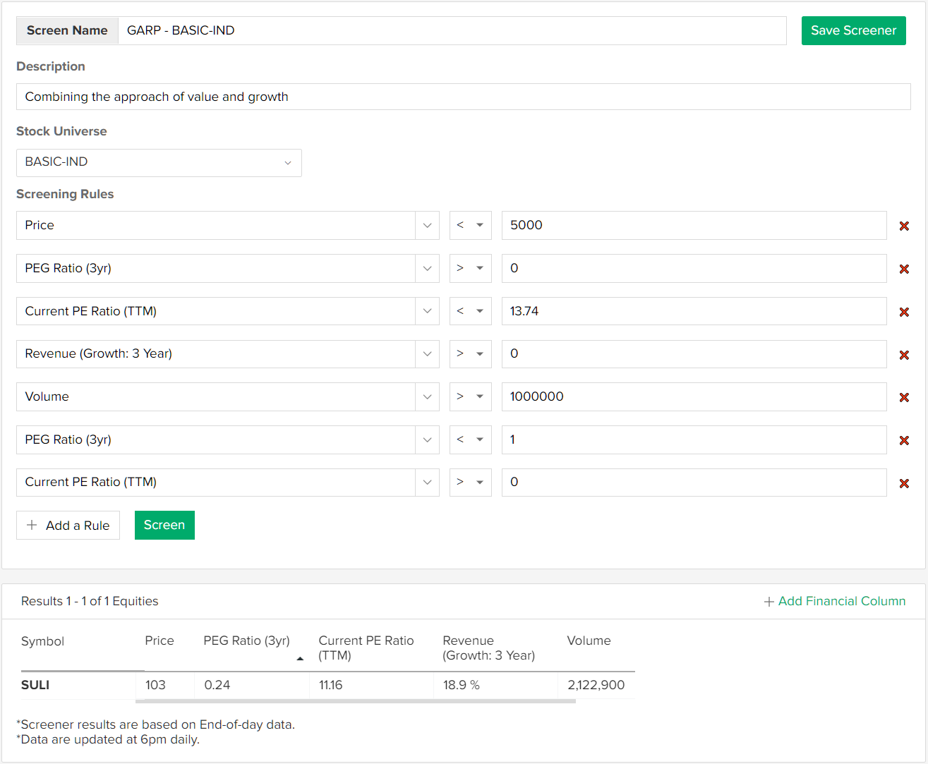

FINANCE (Average P/E ratio in sector: 13.47)
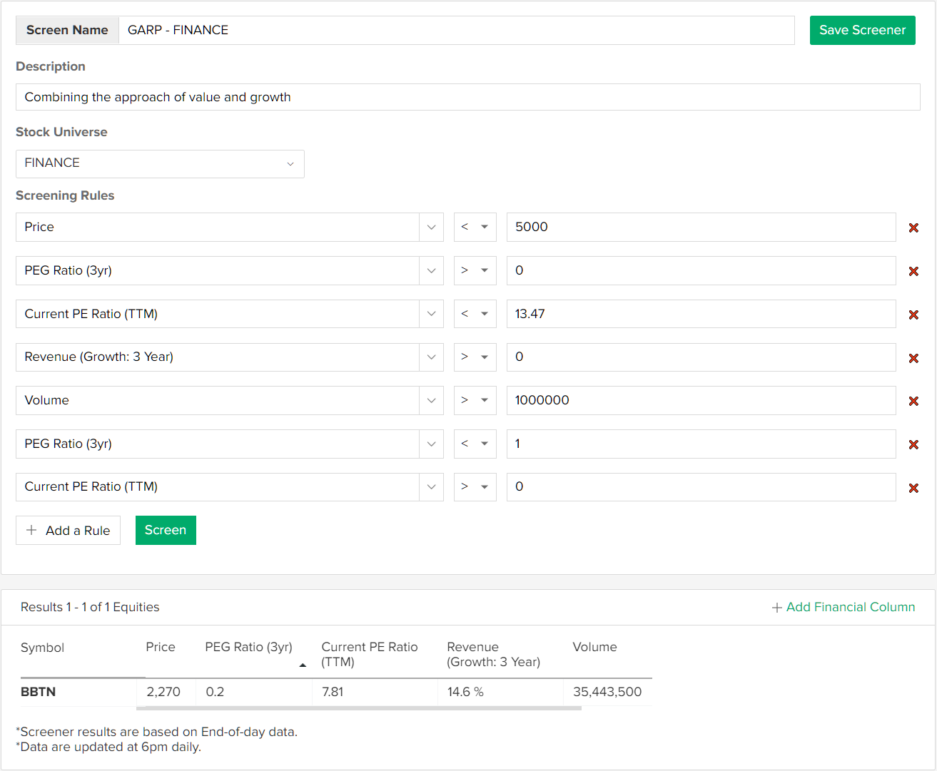

MINING (Average P/E ratio in sector: 9.73)
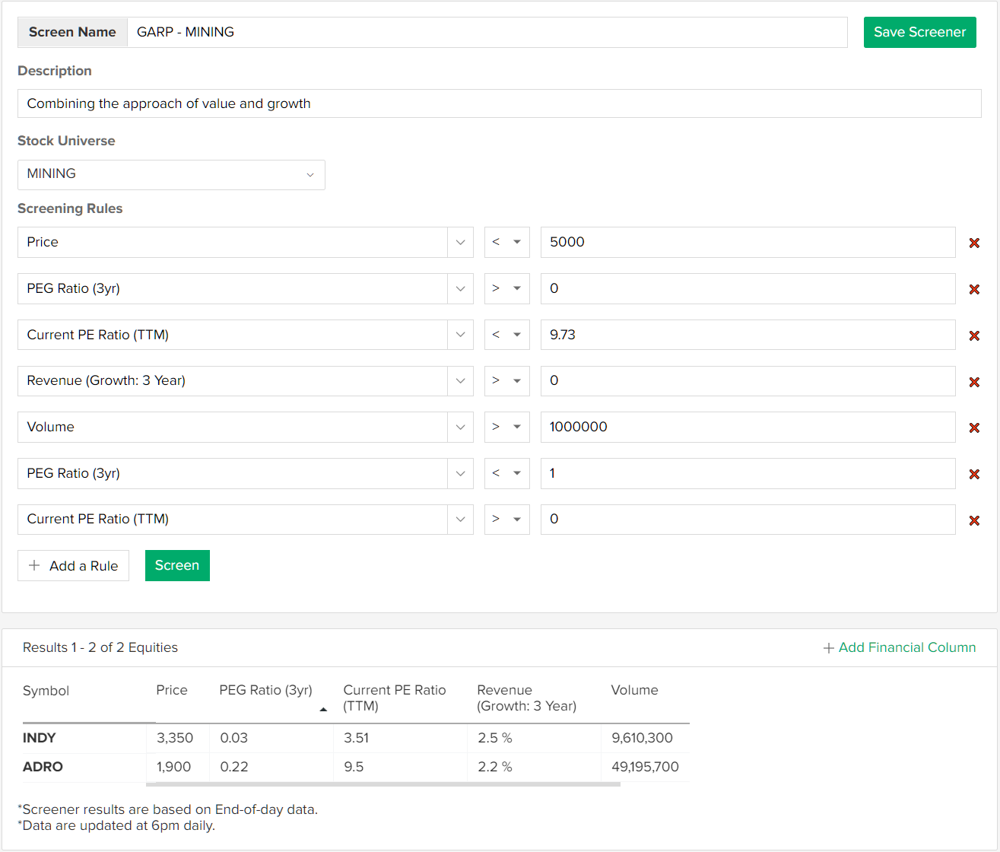

PROPERTY (Average P/E ratio in sector: 10.85)
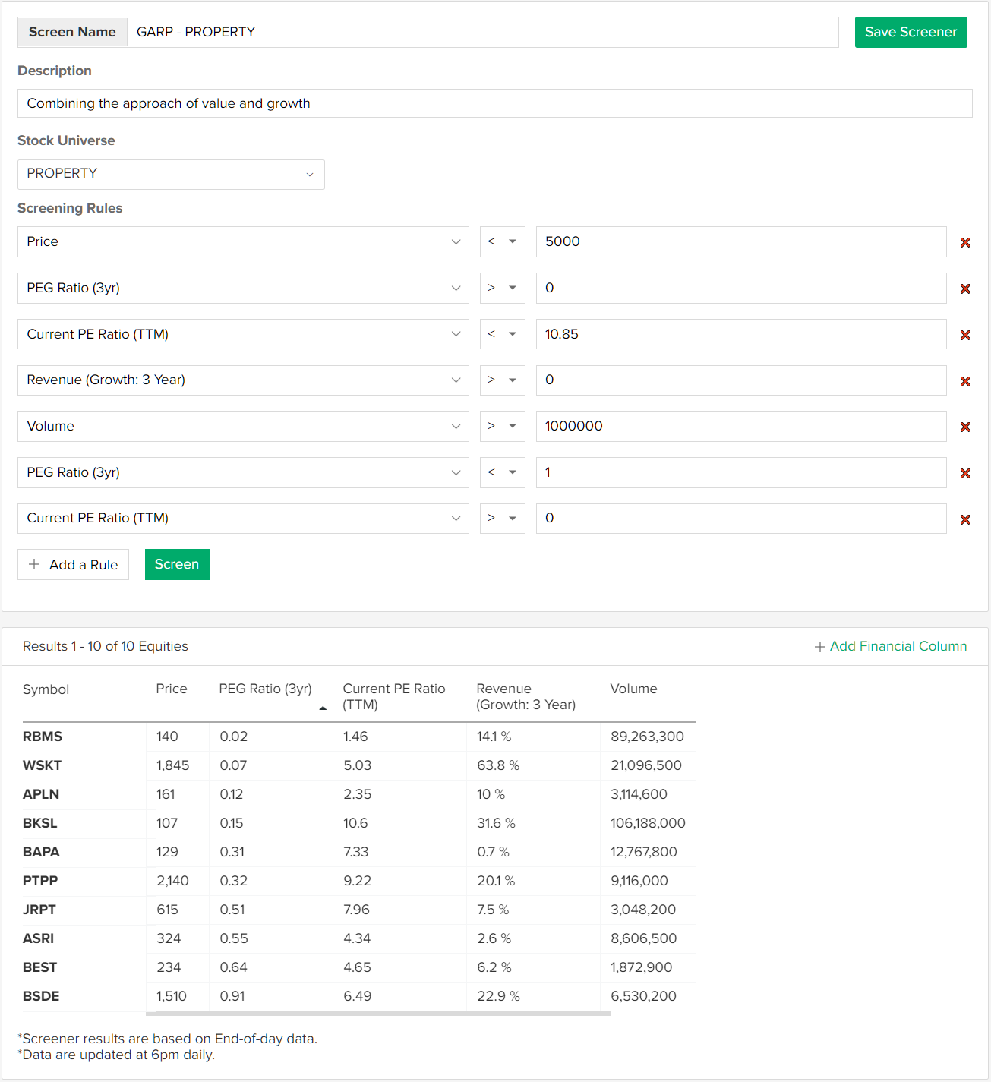

TRADE (Average P/E ratio in sector: 13.14)
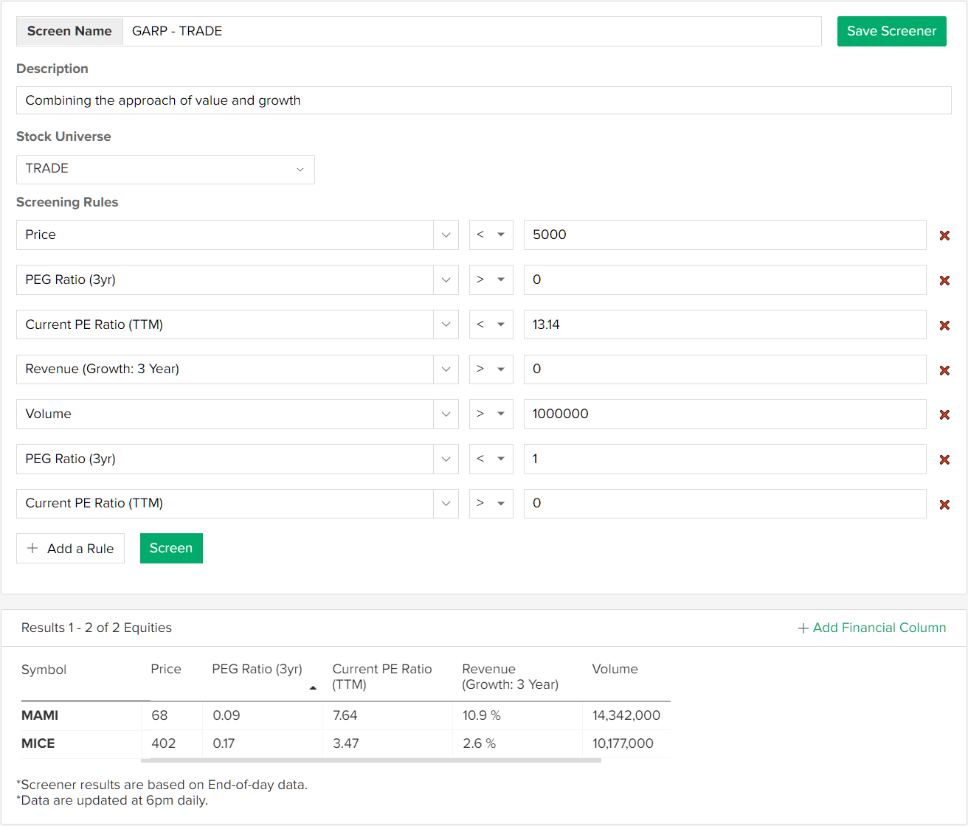

In summary, we get these stocks that satisfy our screening process:
Table 1 Screening Result using GARP Method
No. | Stock | PEG Ratio | Sector
1 | SULI | 0.24 | BASIC-INDUSTRY
2 | BBTN | 0.20 | FINANCE
3 | INDY | 0.03 | MINING
4 | ADRO | 0.22 | MINING
5 | RBMS | 0.02 | PROPERTY
6 | WSKT | 0.07 | PROPERTY
7 | APLN | 0.12 | PROPERTY
8 | BKSL | 0.15 | PROPERTY
9 | BAPA | 0.31 | PROPERTY
10 | PTPP | 0.32 | PROPERTY
11 | JRPT | 0.51 | PROPERTY
12 | ASRI | 0.55 | PROPERTY
13 | BEST | 0.64 | PROPERTY
14 | BSDE | 0.91 | PROPERTY
15 | MAMI | 0.09 | TRADE
16 | MICE | 0.17 | TRADE

CREATING PORTFOLIO
To choose stocks from those 16 stocks that pass our screening process, we need to make sure that:
- There is no more than 1 stock for each sector in our portfolio to satisfy diversification needs
- There must be signal/indication of timing to buy stock using technical analysis

This screening process will be repeated every week before creating portfolio.

